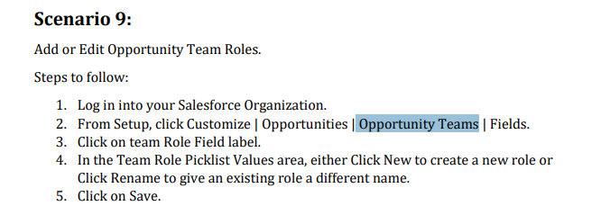

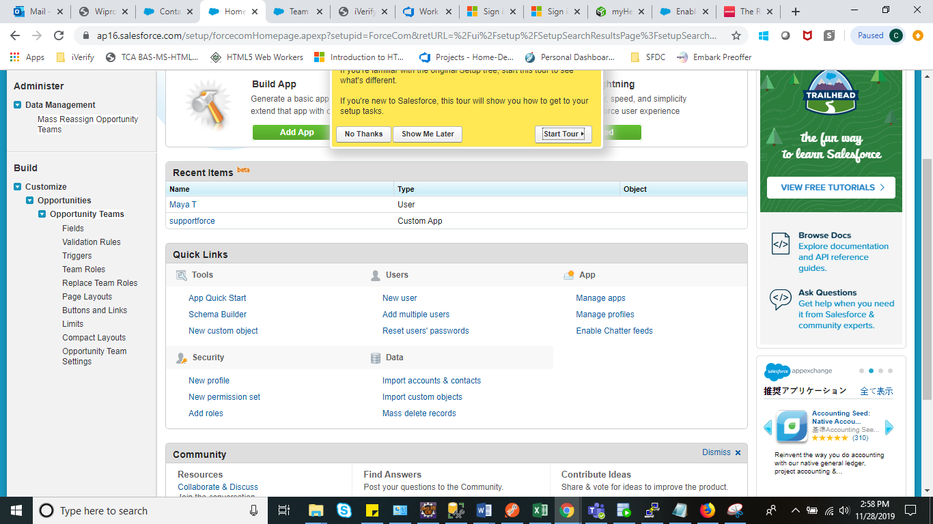

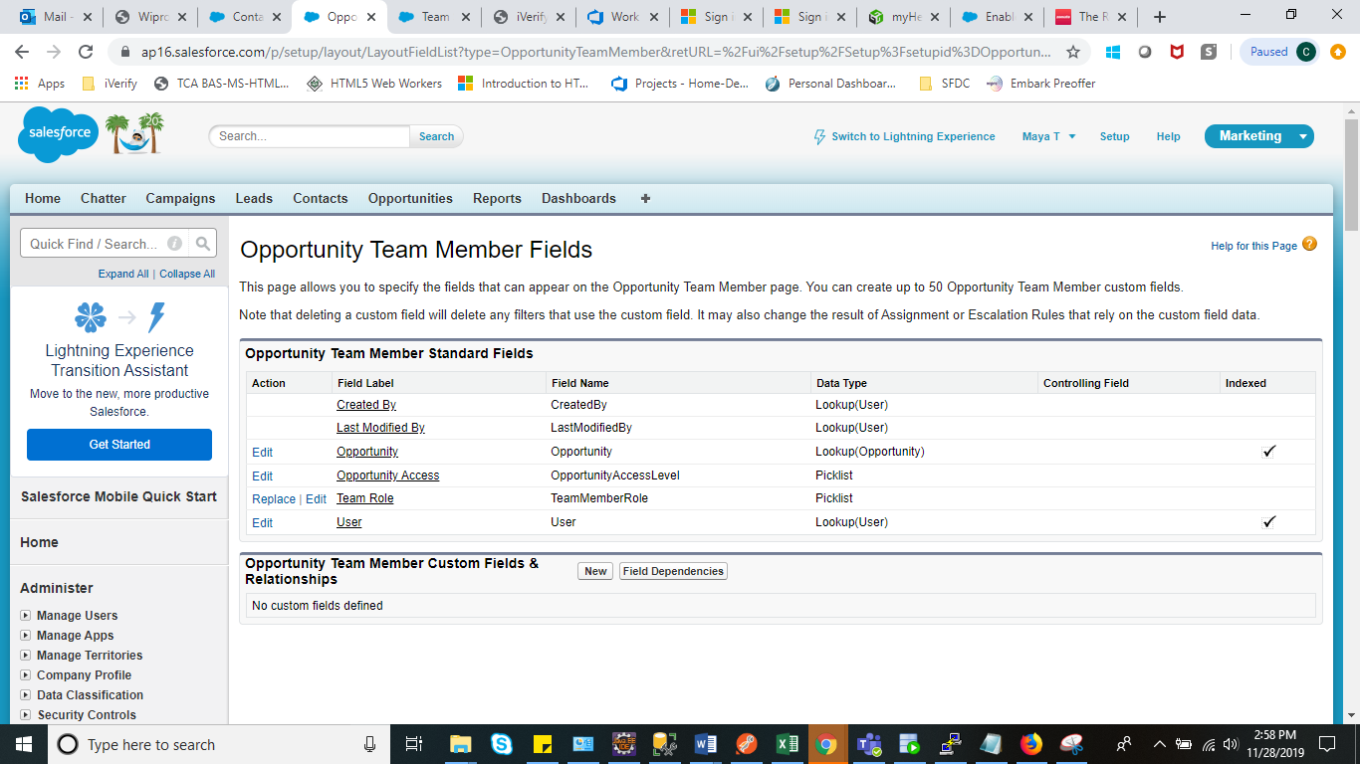

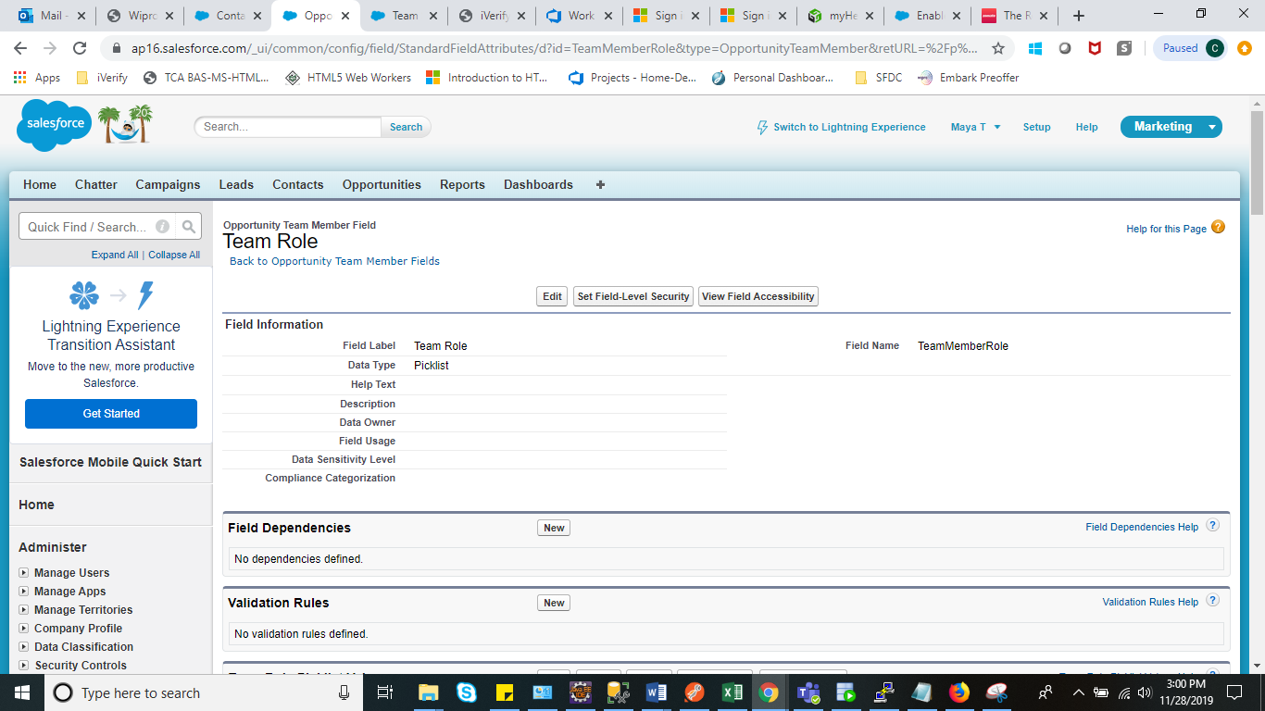

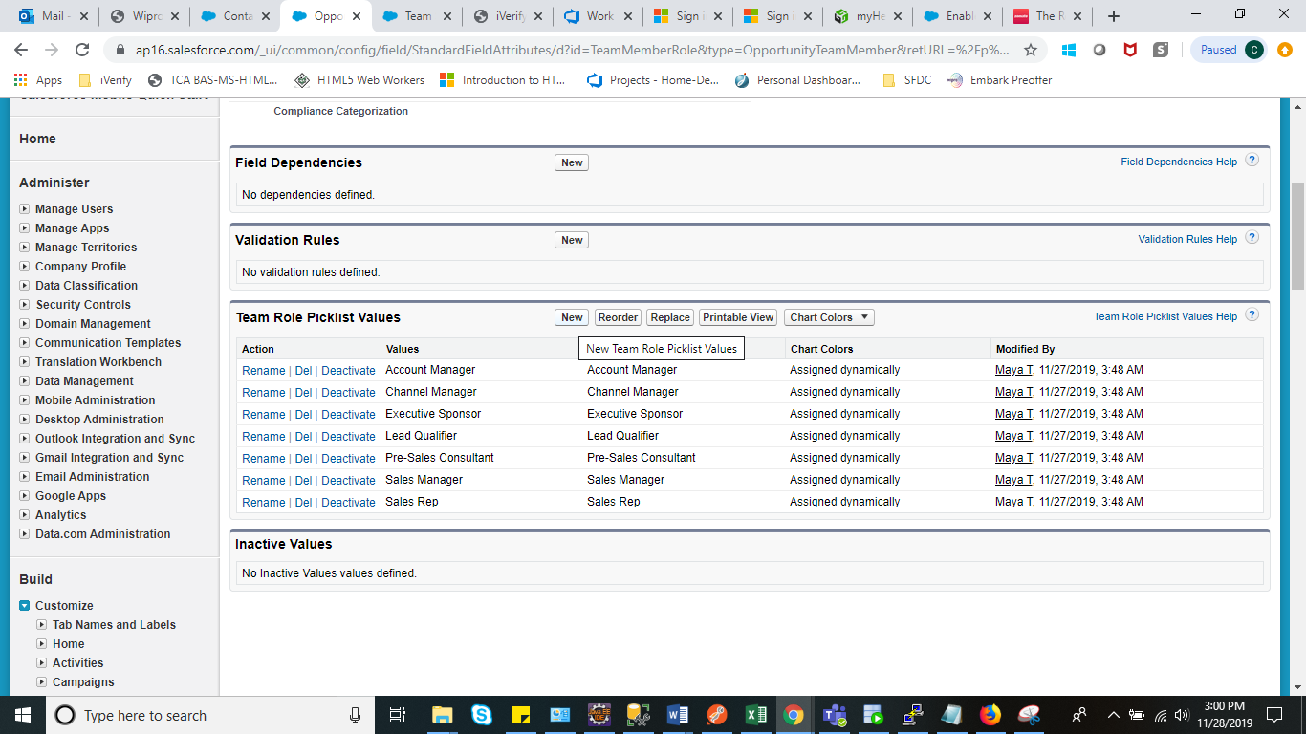

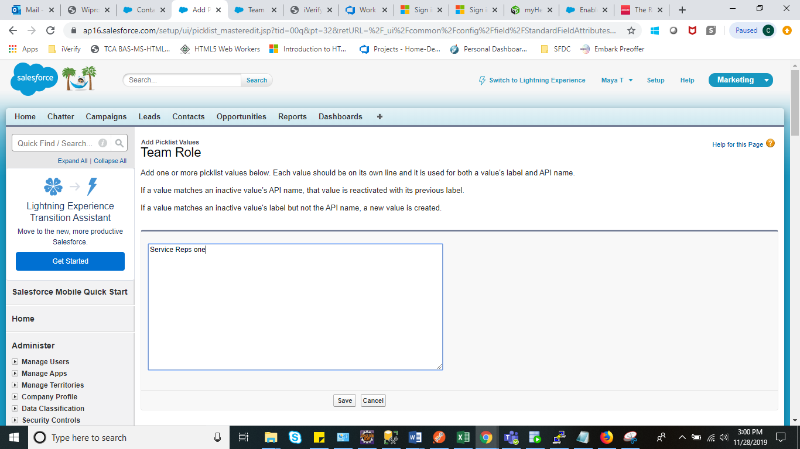

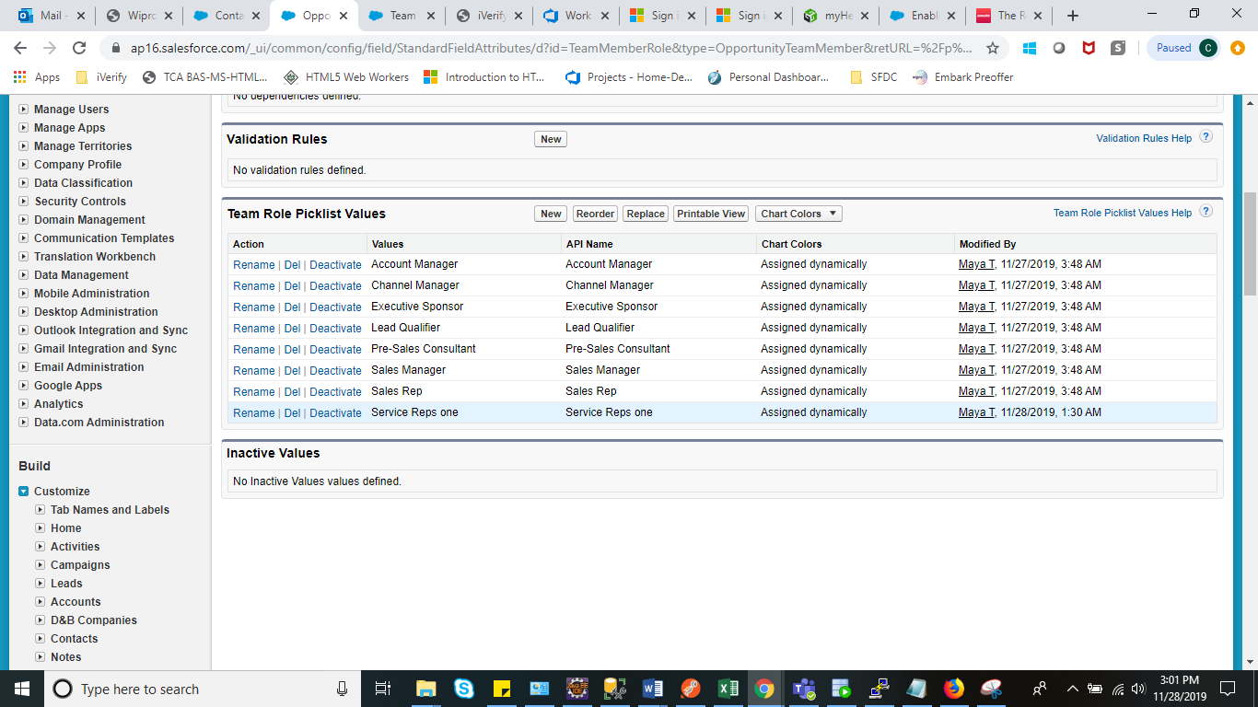

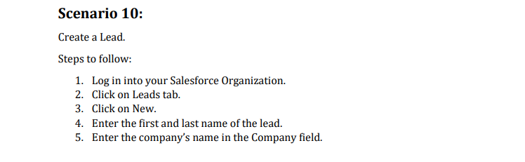

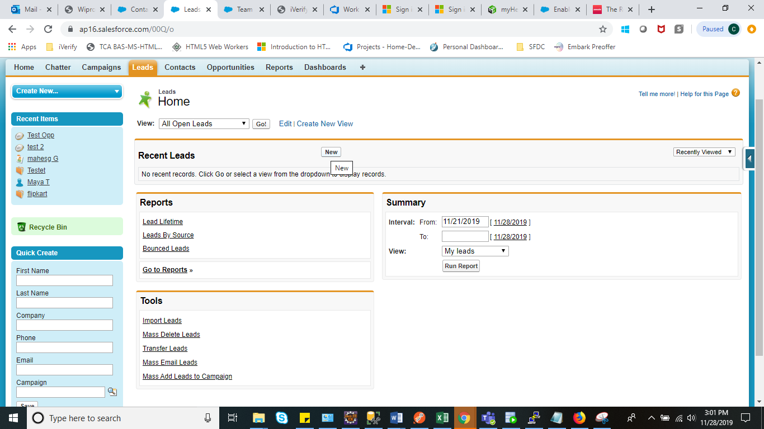

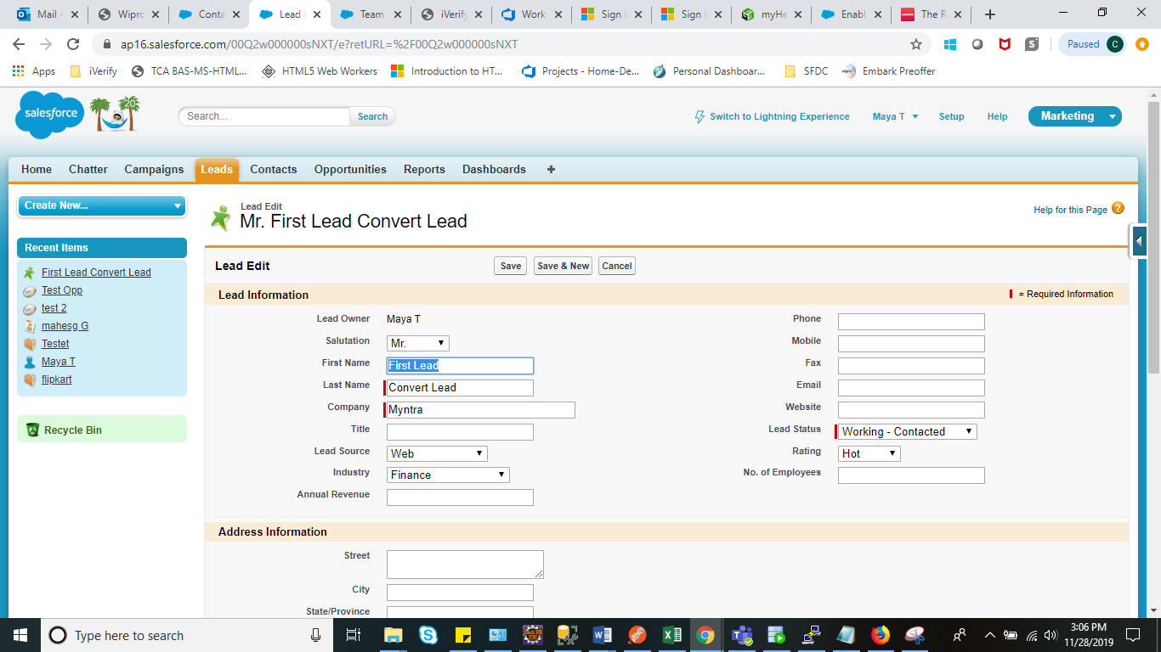

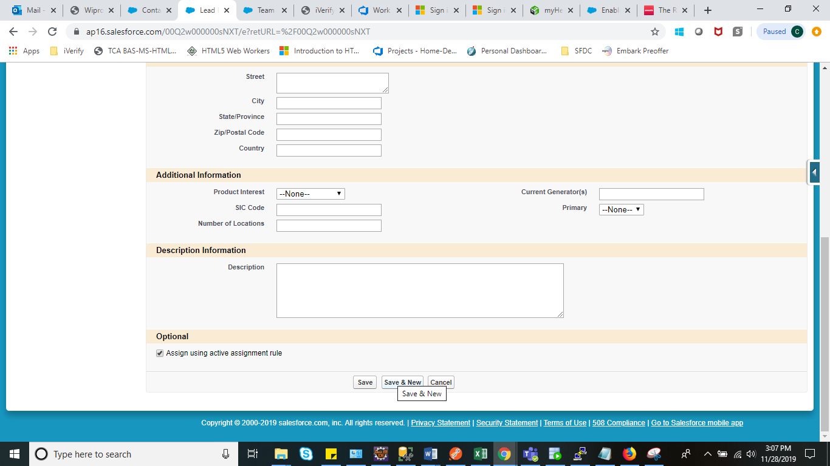

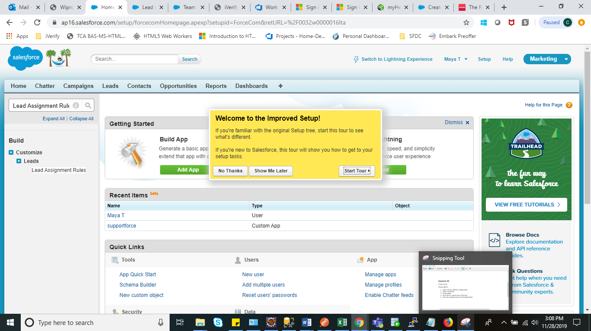

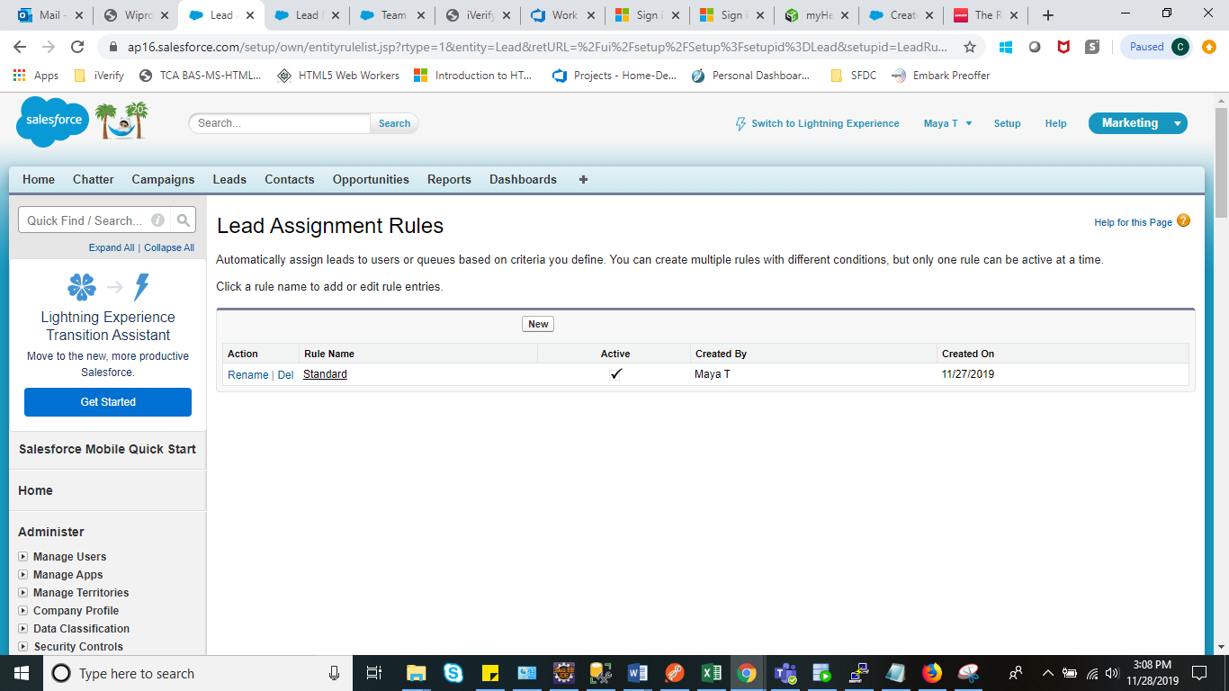

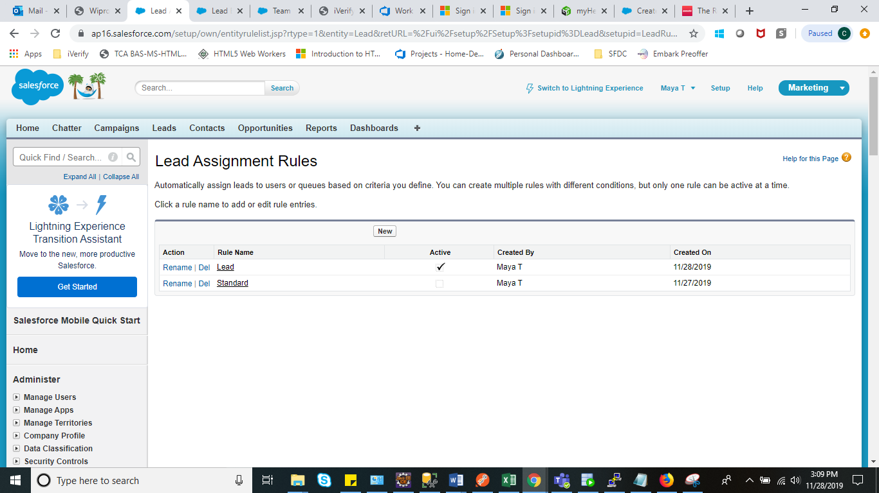

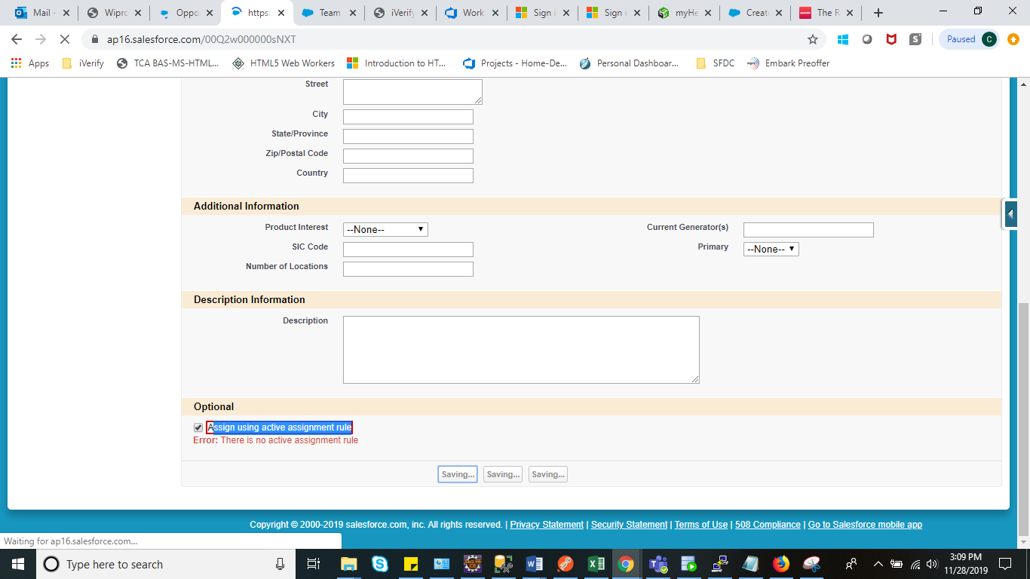

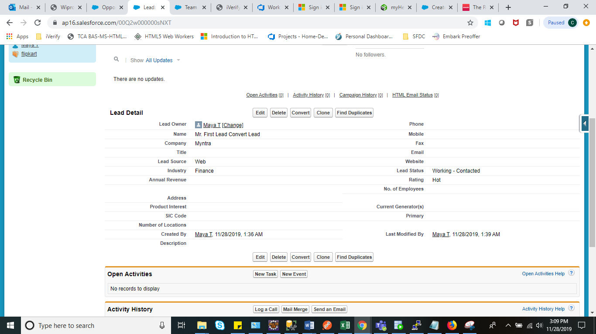

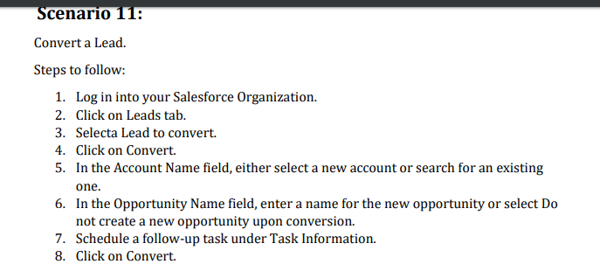

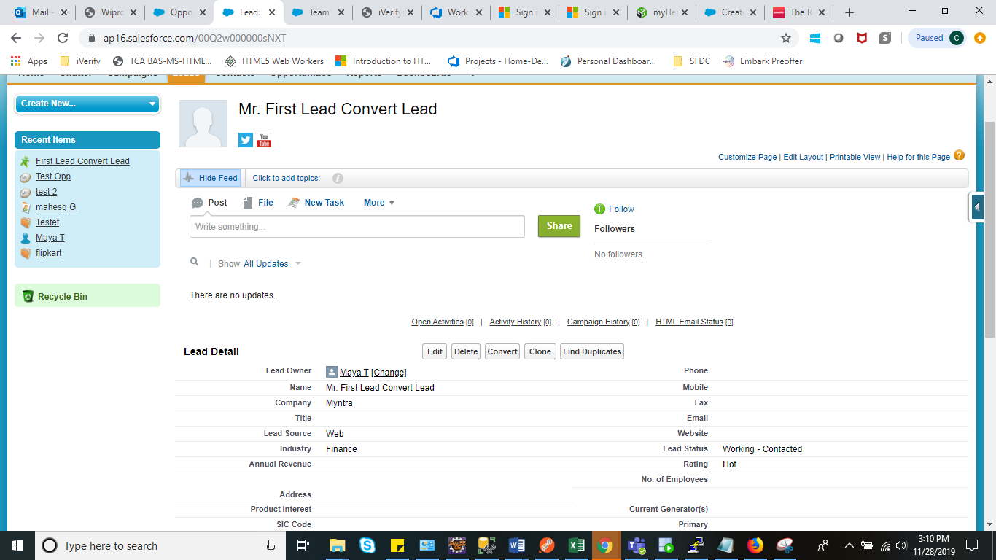

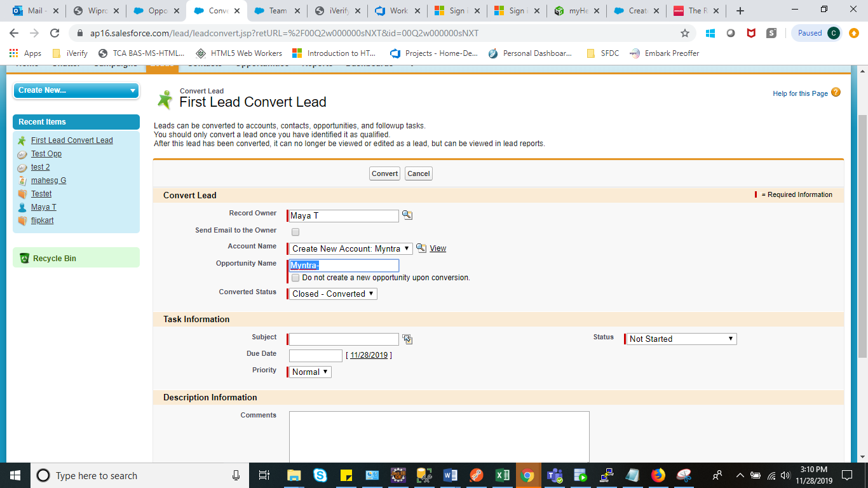

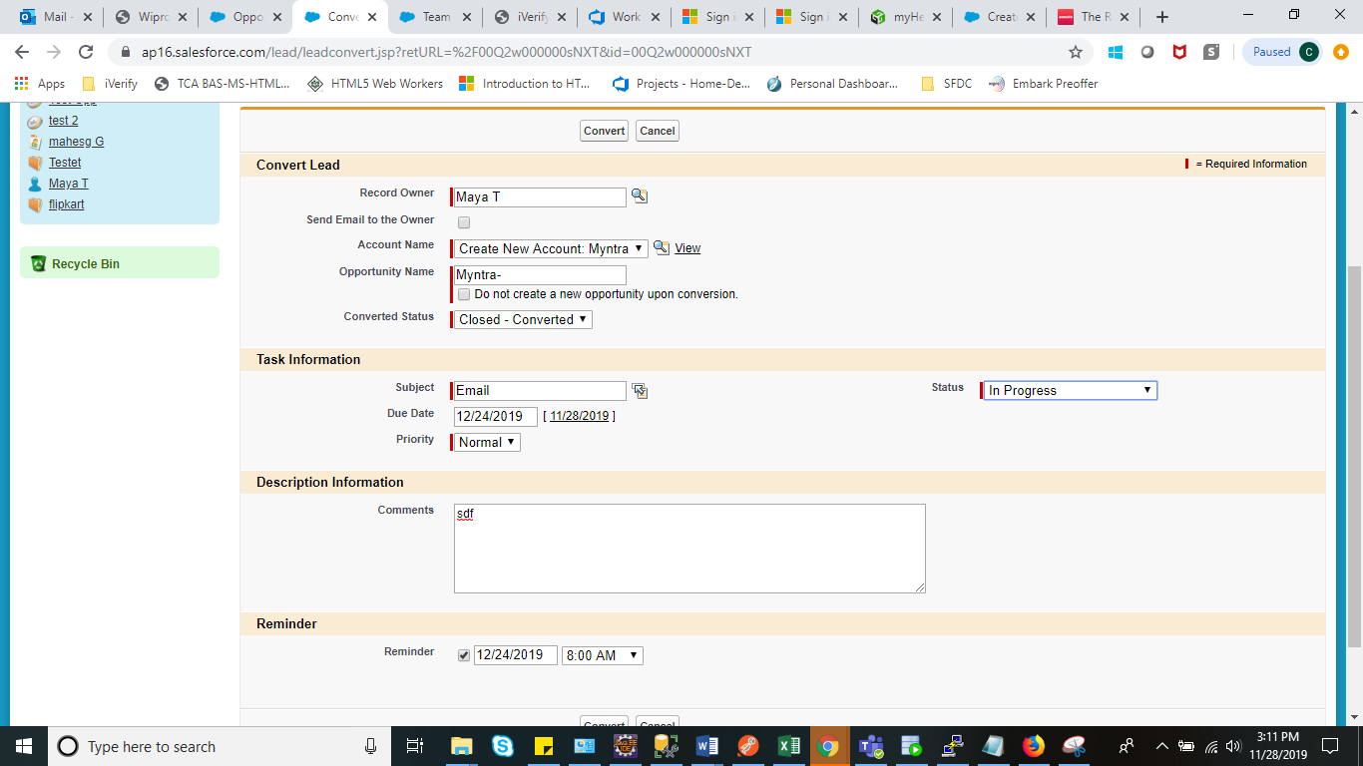

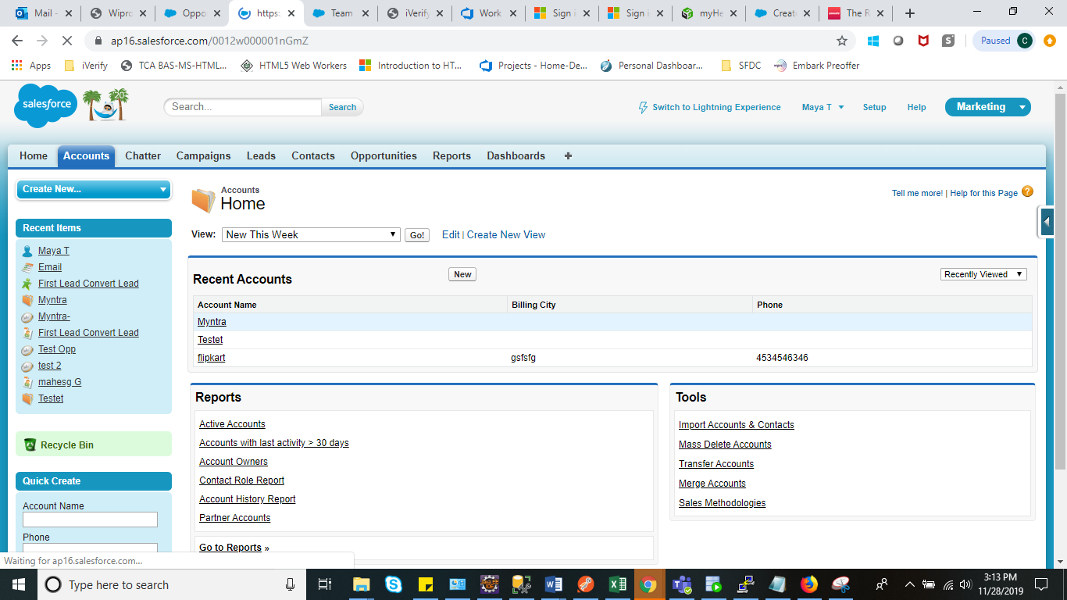

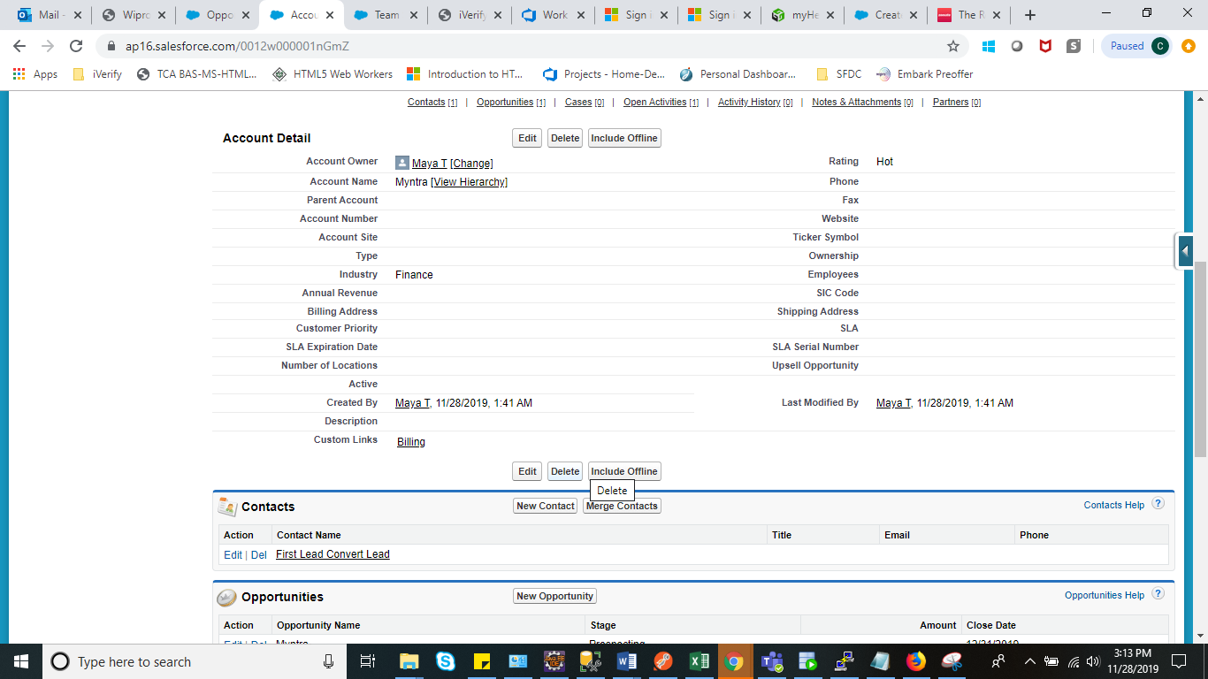

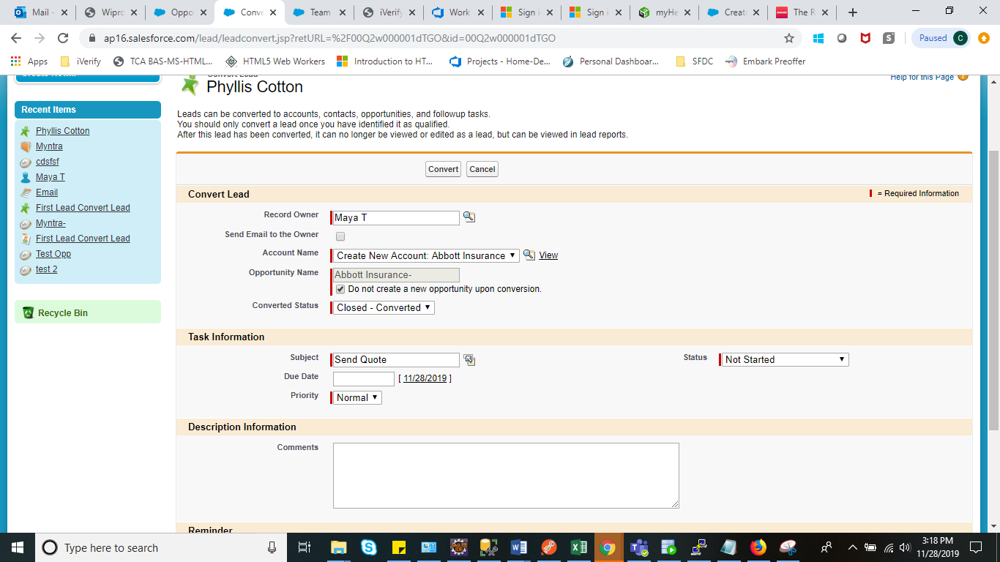

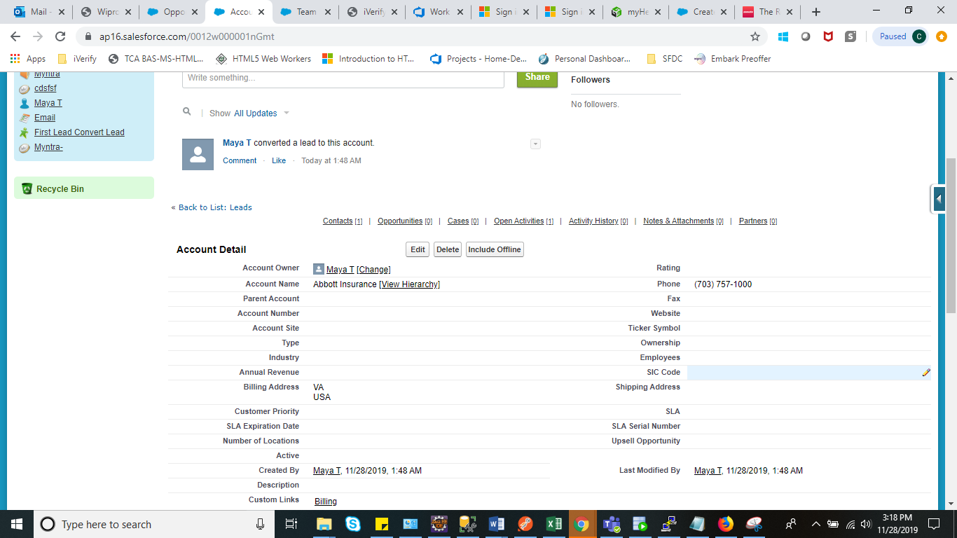 **Scenario 12:**

Build a report, dashboard for leads by source and create a filter for the dashboard.

Steps to follow:

1. Log in into your Salesforce Organization.
2. Click on the Reports tab.

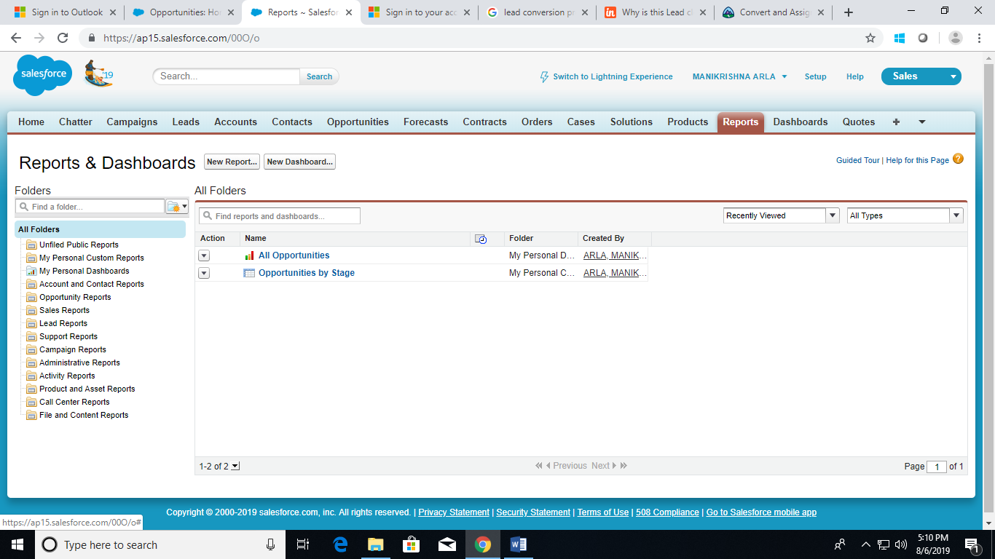

1. Click on New report.

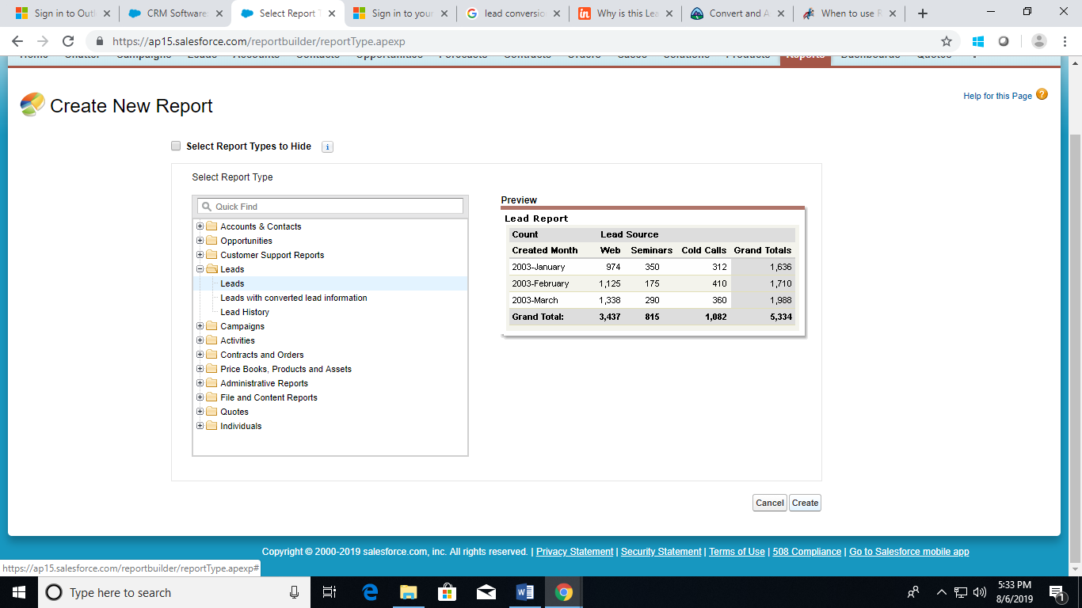

1. Select the ‘Leads’ report type and click Create.
2. Apply the following filter:
3. Select All Leads for Show.
4. Select Create Date for Date Field.
5. Select All Time for Range.
6. Click Tabular Format and select Summary.

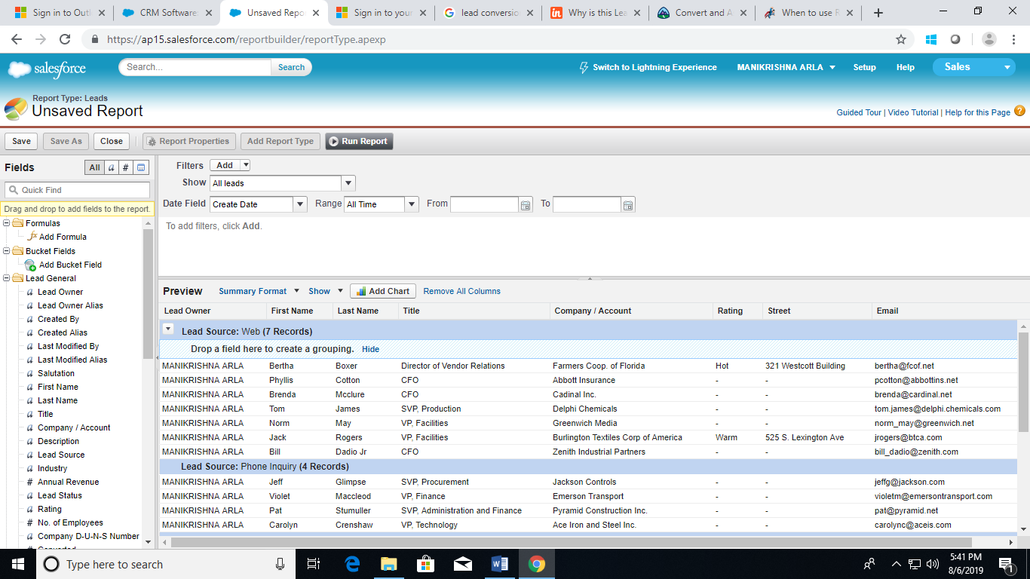

1. Drag Lead Source from the Fields pane to the Preview pane into the Drop a field here to create a grouping section.
2. Click on save button
3. Enter Report label

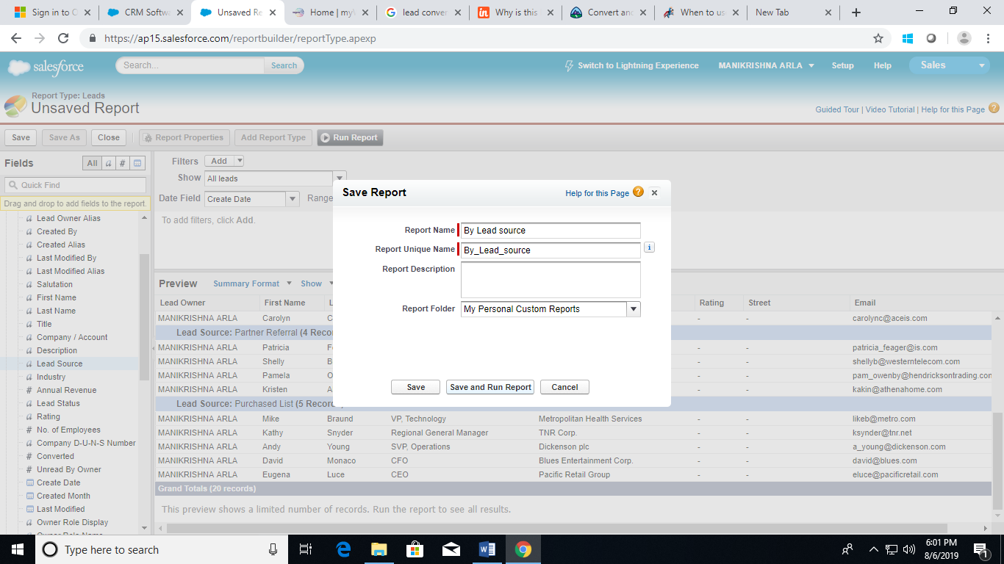

1. Click on save & Run Report.
2. Click on the Reports tab.

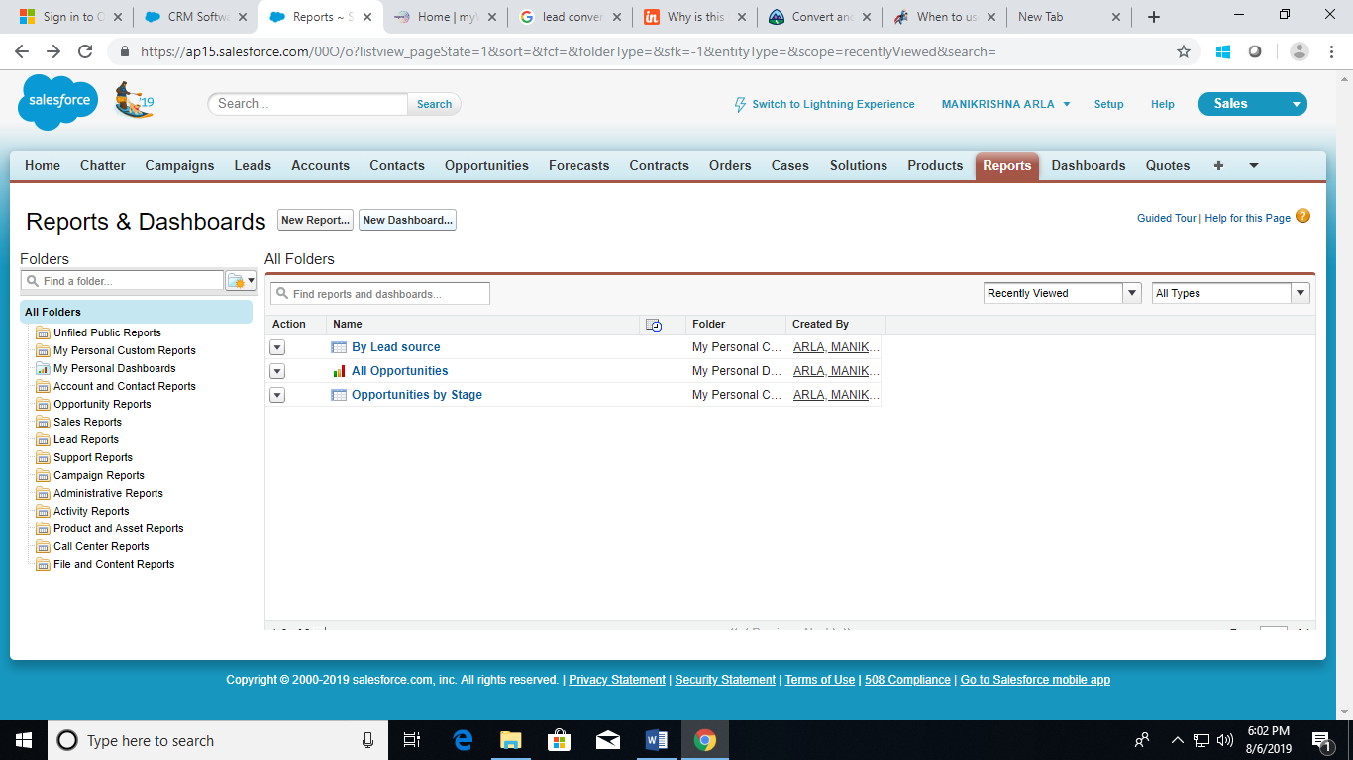

1. Click on New Dashboard.

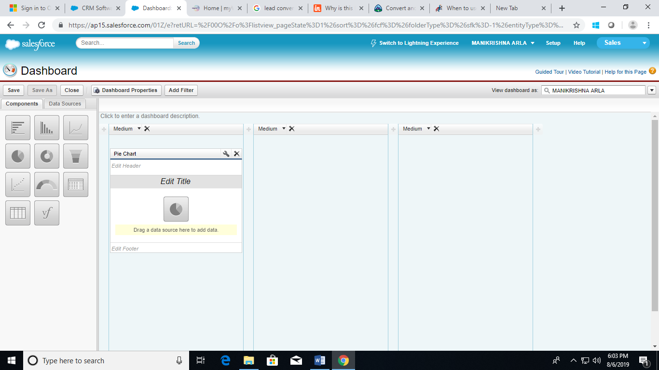

1. From the Components tab, drag and drop the pie chart component onto the preview pane.
2. Click on the Data Sources tab.

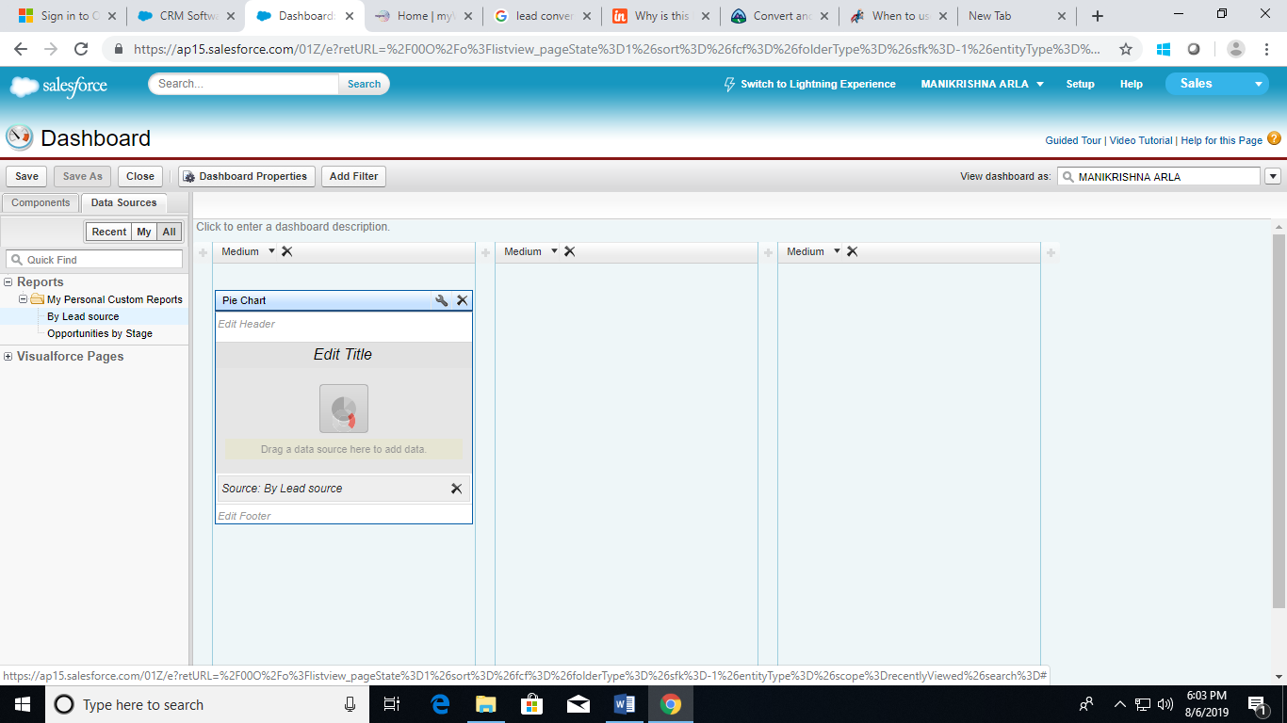

1. Search for the leads report and drag and drop it onto the pie chart component.

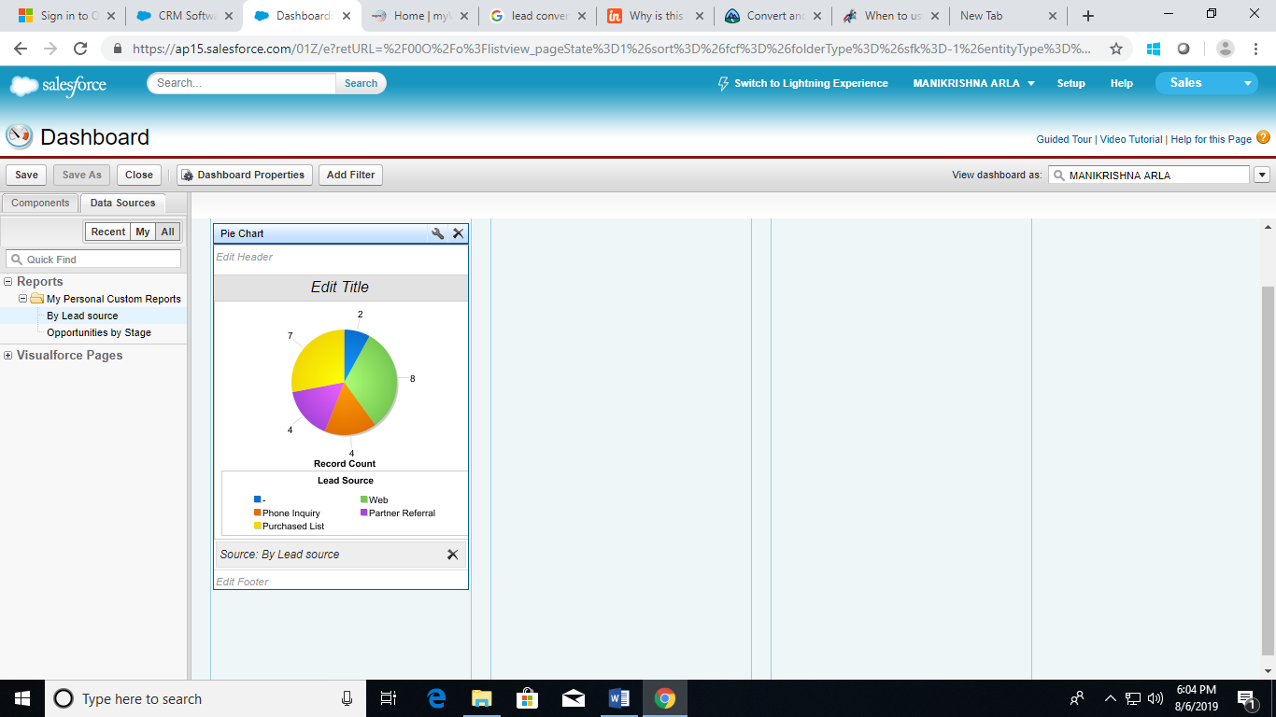

1. Click on the wrench icon in the upper right corner of the dashboard component.
2. Select Sort Rows By and choose Label Descending. This will place the values on the component in alphabetical order.
3. Select Legend Position and choose On Chart.
4. Click on OK.
5. Click on Save and name the dashboard.
6. Enter a description.
7. Click on Save and Run the dashboard.

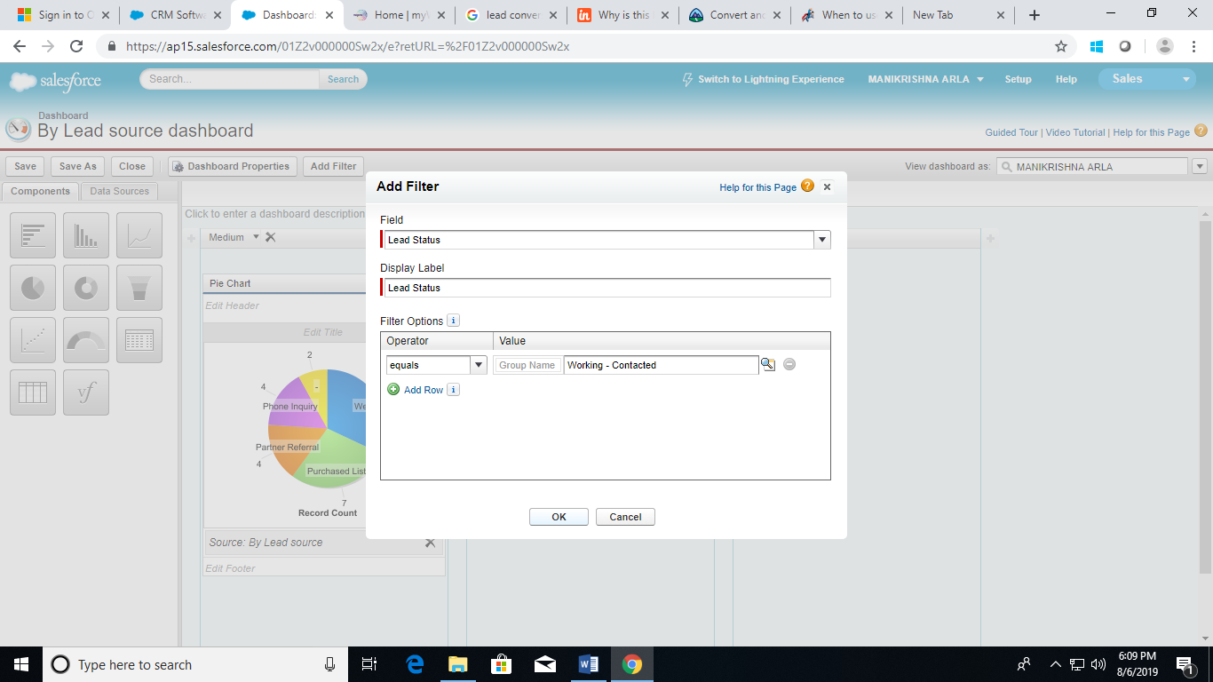

1. Click Edit on your Leads Dashboard, then click Add Filter.
2. Select the Lead Status field to filter on from the Field drop-down.
3. Give your filter a display label to identify it.
4. Under Filter Options, select an operator and provide one or more values to filter by.
5. Use the Group Name field to give your filter a name.

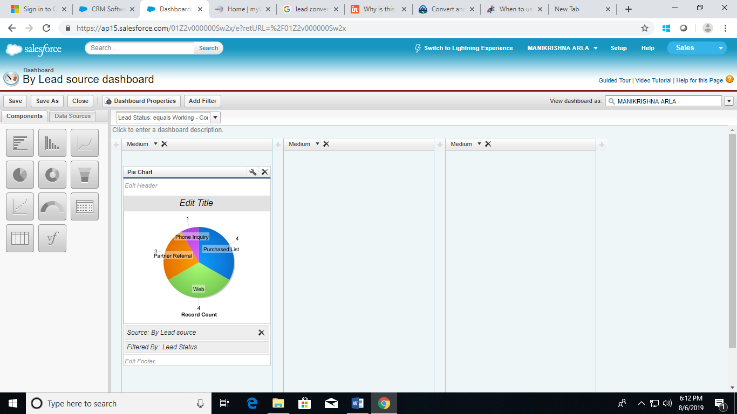

1. Click OK, then Close and Save and Close to return to your dashboard.

**Scenario 13:**

Set up a dynamic dashboard.

Steps to follow:

1. Log in into your Salesforce Organization.
2. Click on the Dashboards tab.

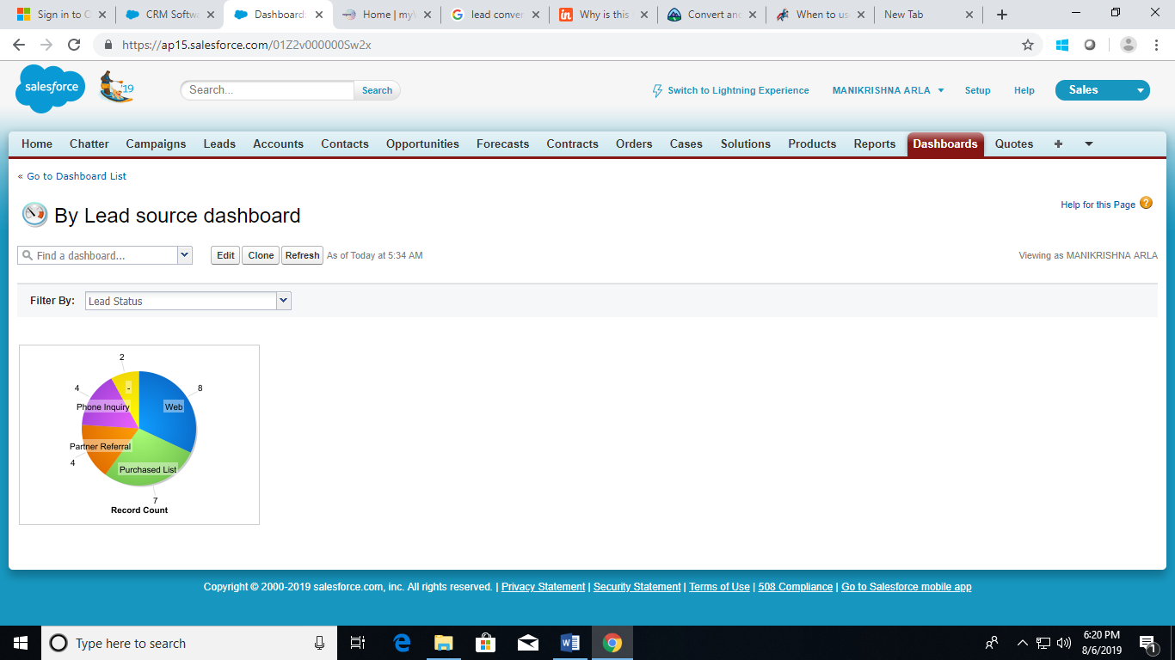

1. Click on New dashboard or edit an existing one.
2. Click View dashboard as drop-down button next to the View dashboard as field.
3. Select Run as logged-in user.

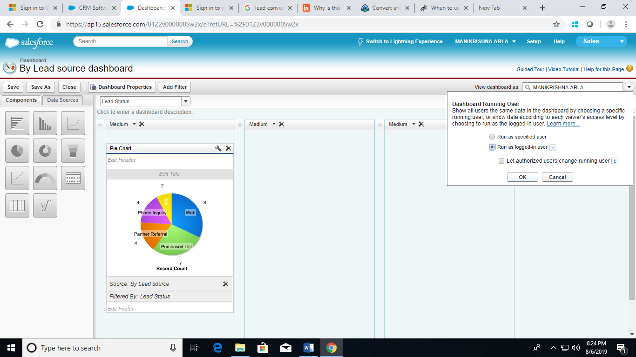

1. Click OK.
2. In the View dashboard as field, enter a running user.
3. Click on Save.

**Scenario 14:**

Add a Report and Embedded Charts.

Steps to follow:

1. Log in into your Salesforce Organization.
2. Open a Report in Report builder.

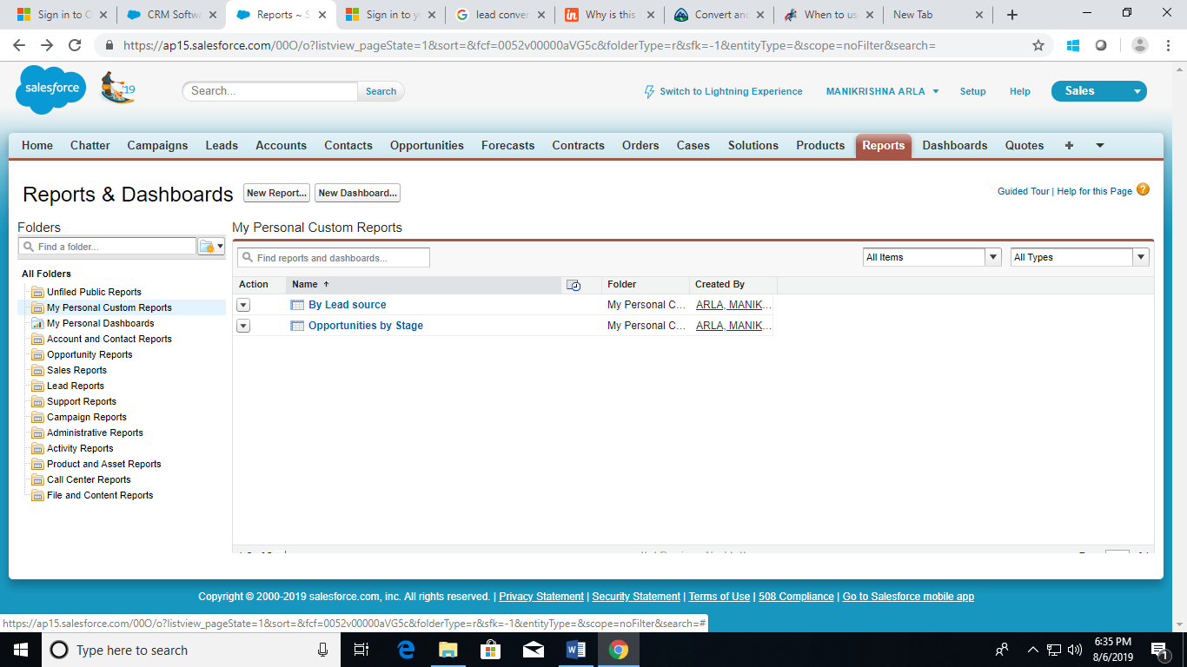

1. Click on customize

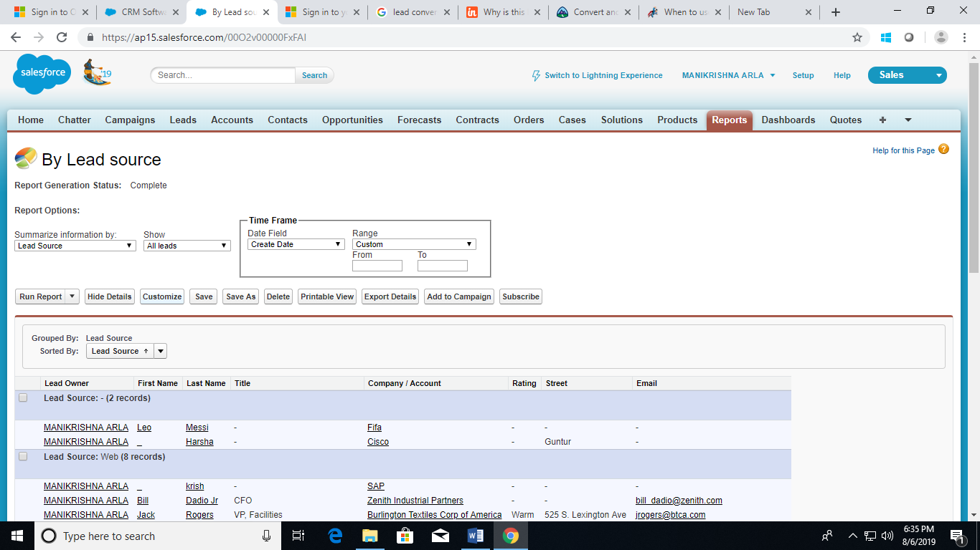

1. Click Add Chart in report builder.

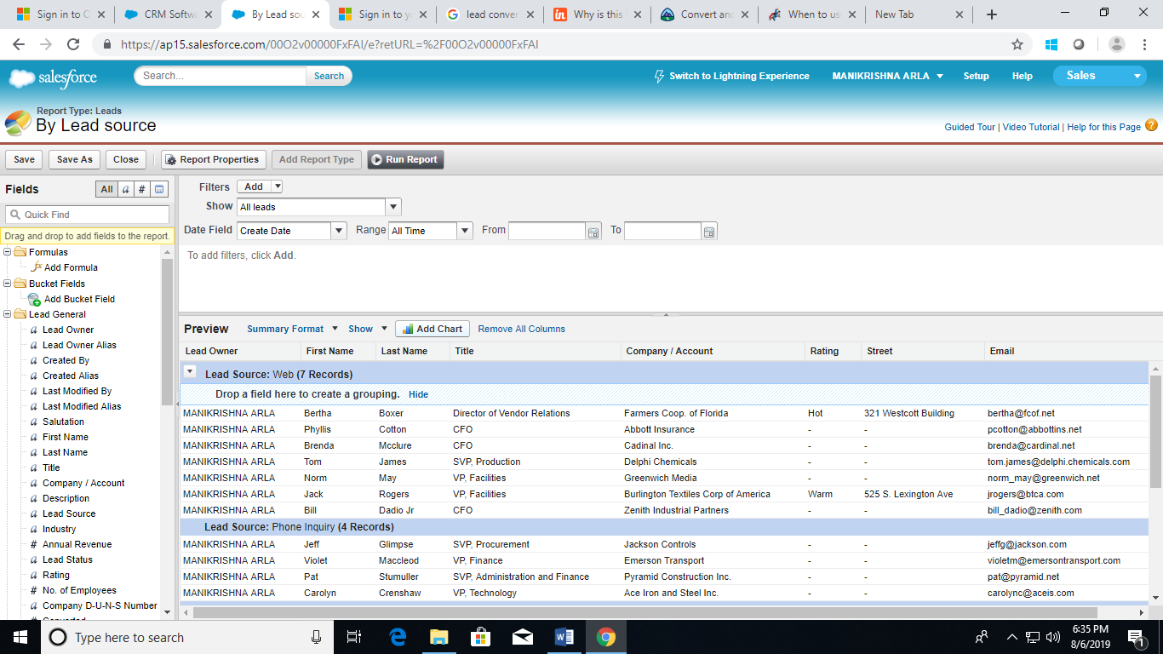

1. Select a chart type.

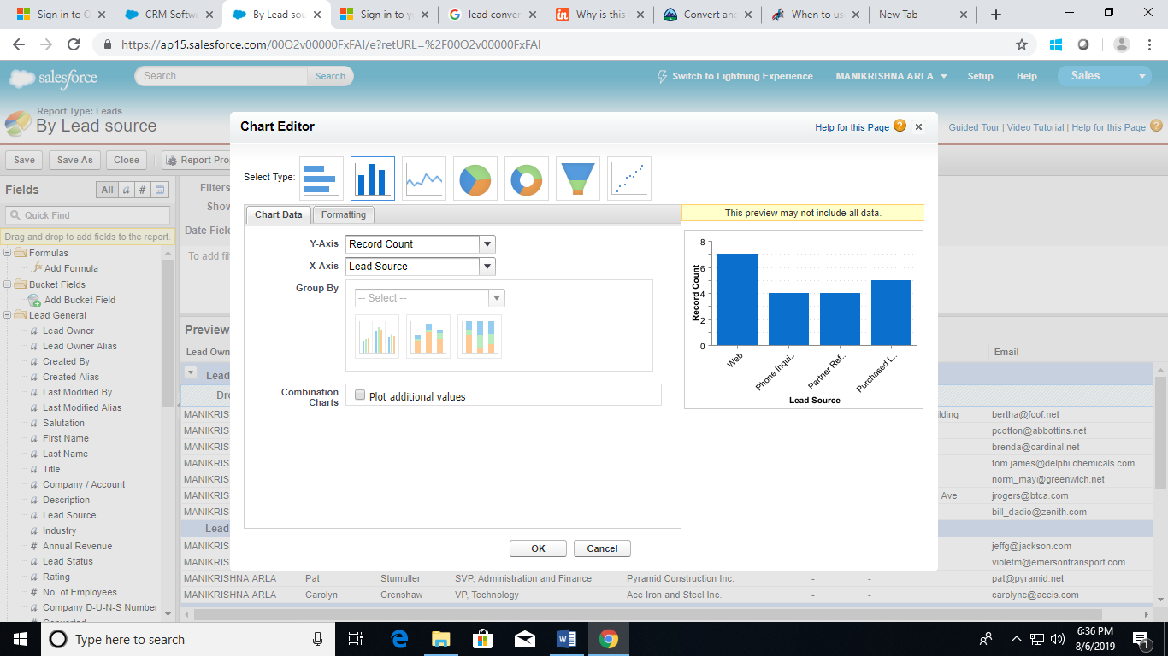

1. Enter the appropriate settings on the Chart Data tab for the chart type you selected.
2. Enter the appropriate settings on the Formatting tab.

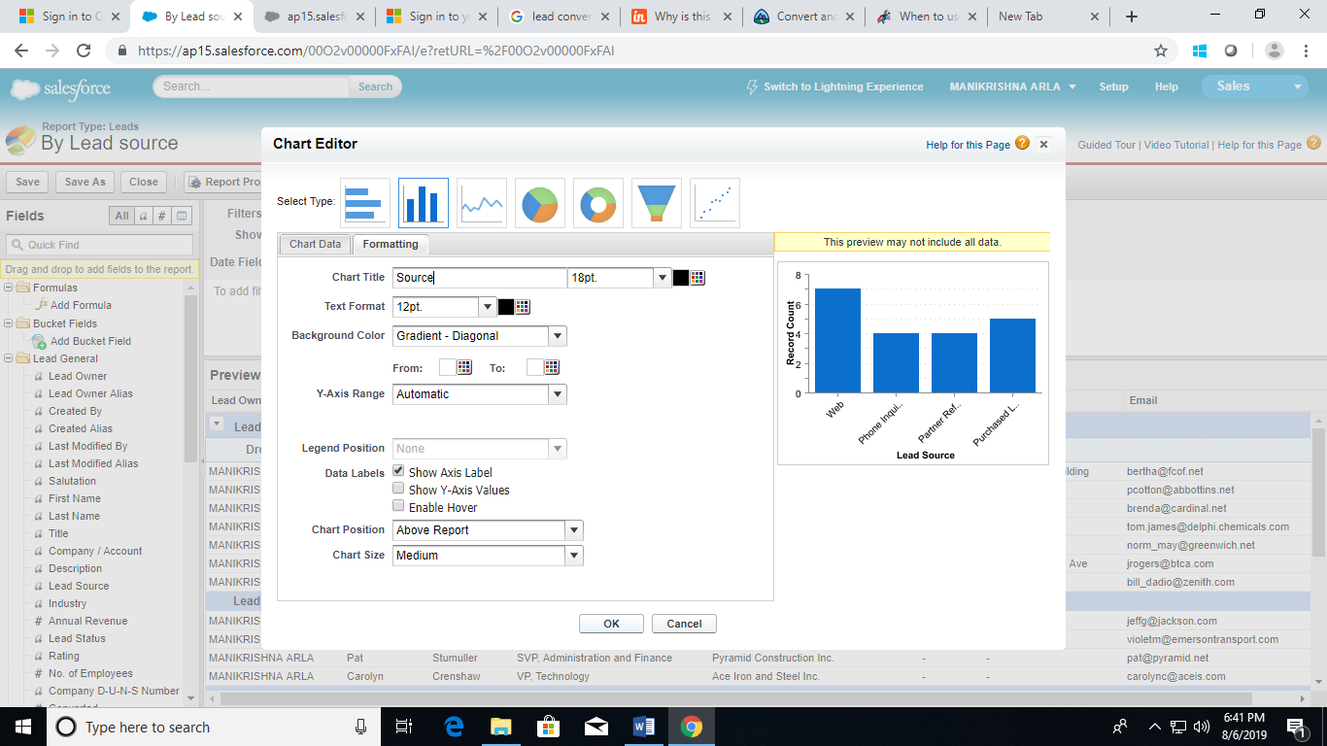

1. Click on OK.
2. From Setup, click Customize | Desired Object | Page Layouts.
3. Click Edit next to the page layout.
4. Click Report Charts.
5. In the Quick Find box, type the name of the report and click the Quick Find icon to find and select the report chart.

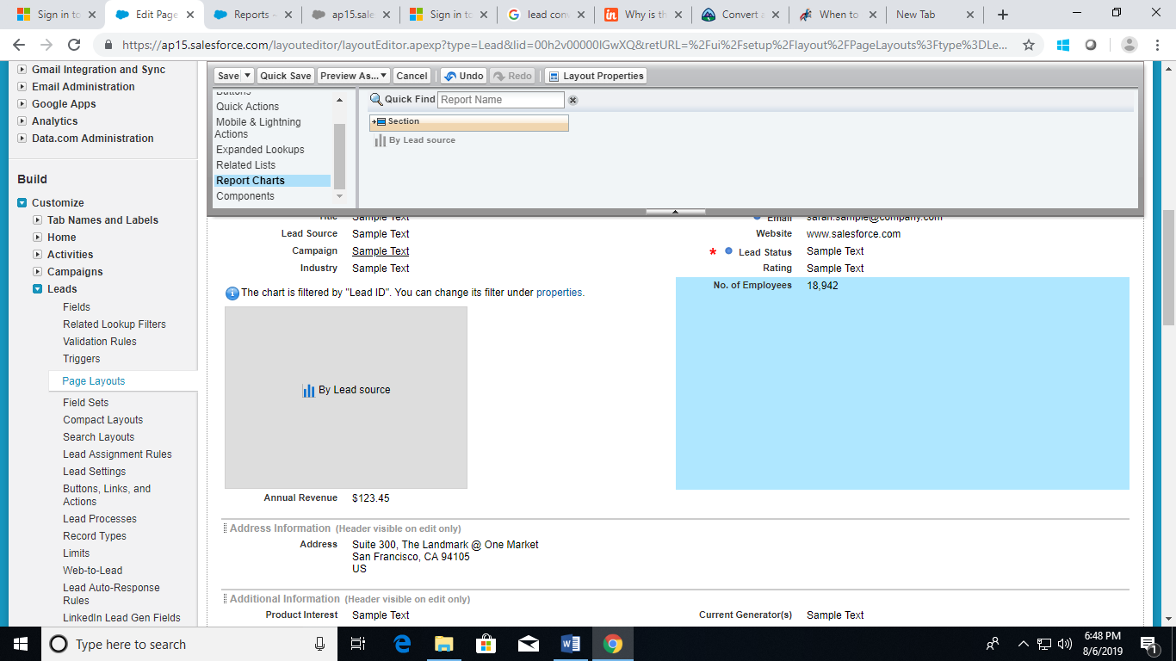

1. Drag the chart to a new or existing section of the layout.
2. Click the Wrench icon on the chart to customize it.

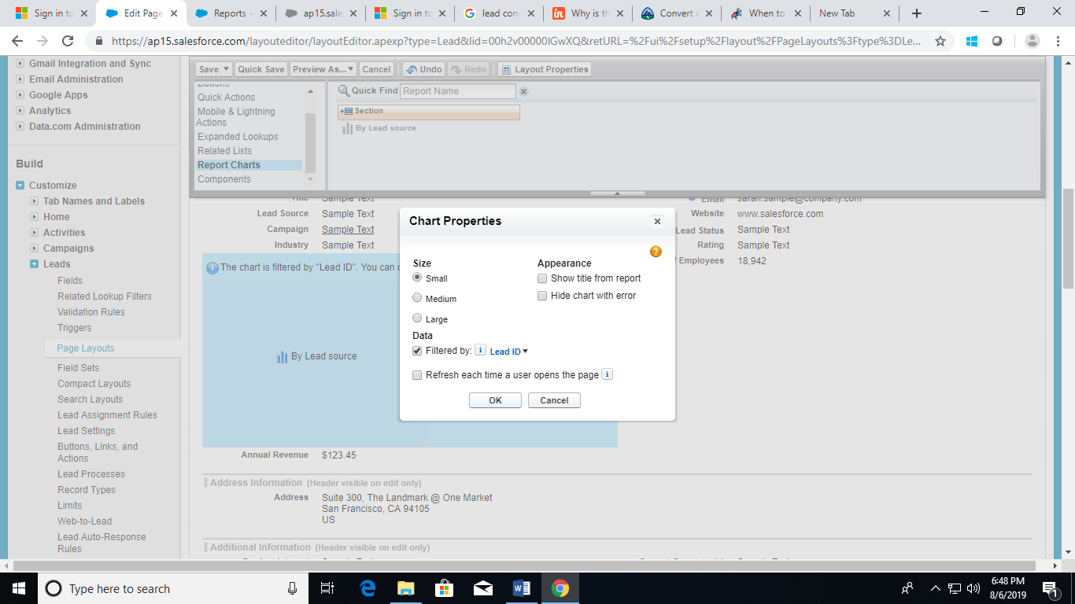

1. Click on Save.

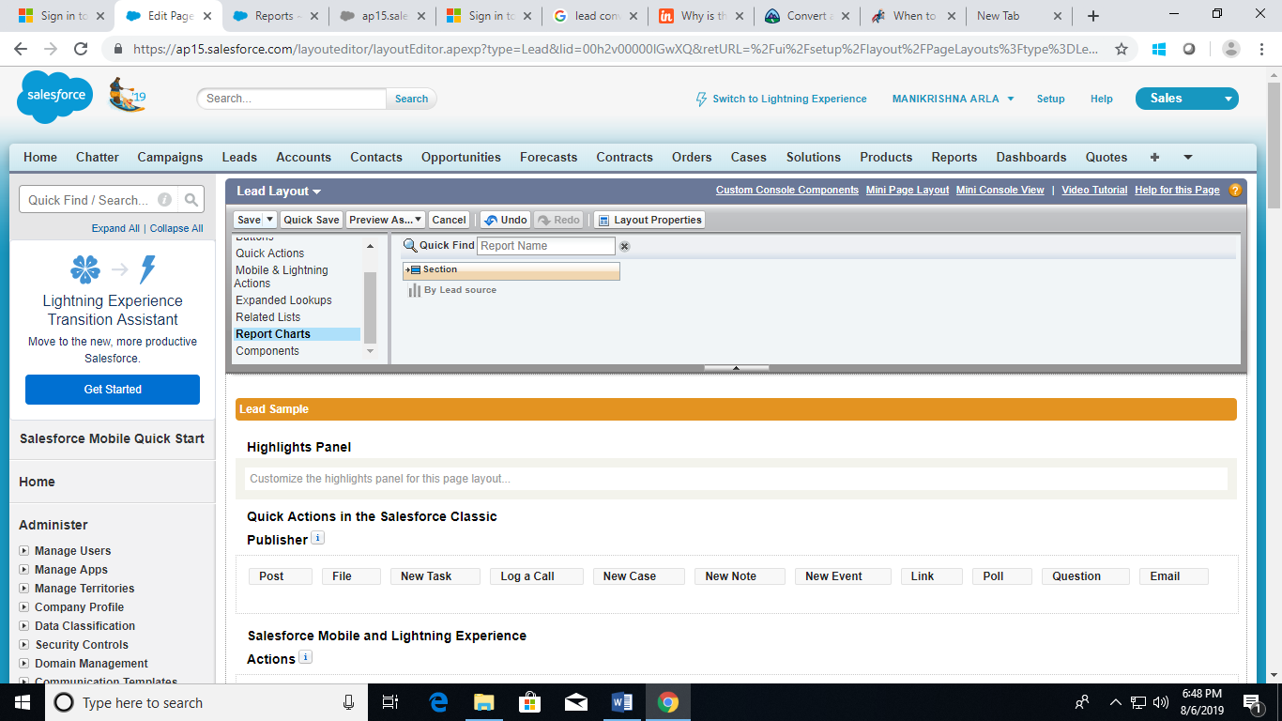

**Scenario 15:**

Display an account field on the Contact Detail page.

Steps to follow:

1. Log in into your Salesforce Organization.
2. Navigate to Object Manager.

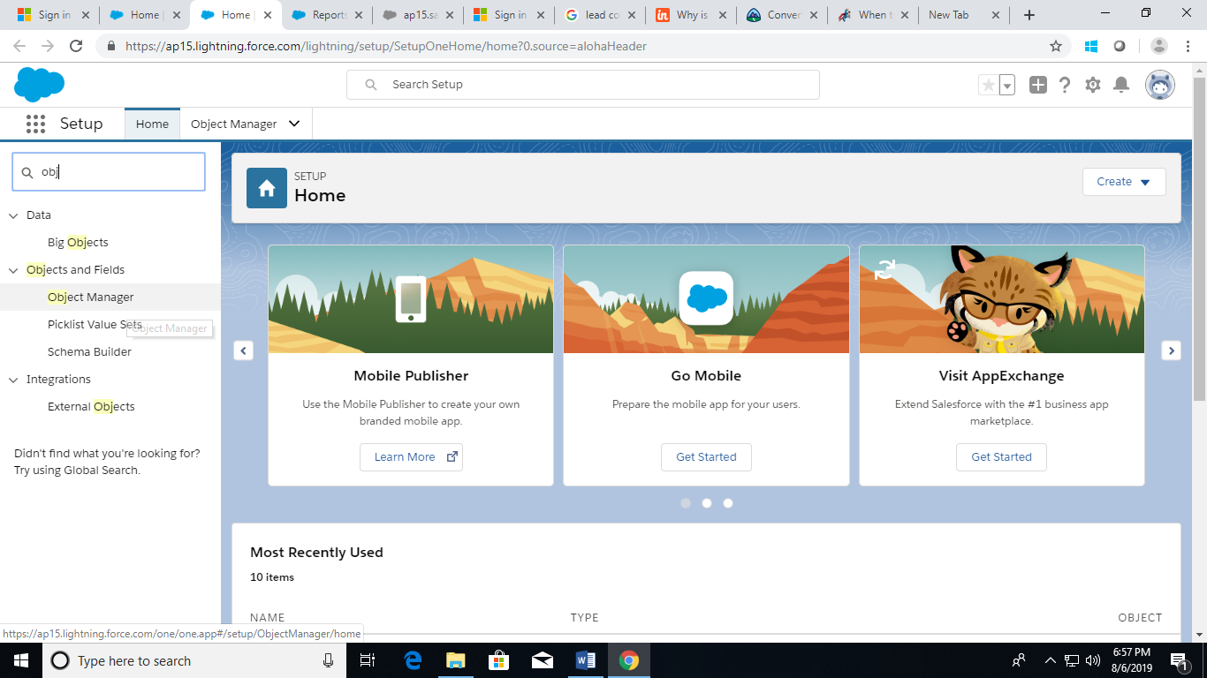

1. Click Account | Fields & Relationships and click New.

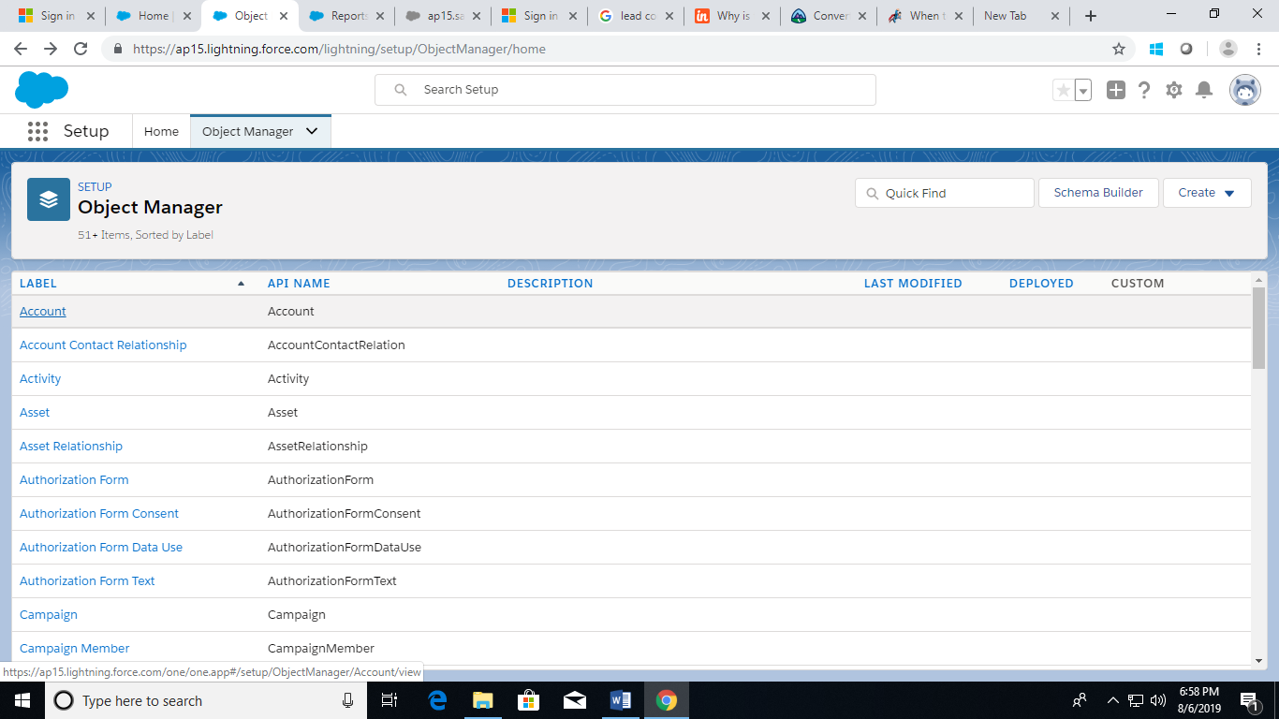

1. Select Formula and click Next.

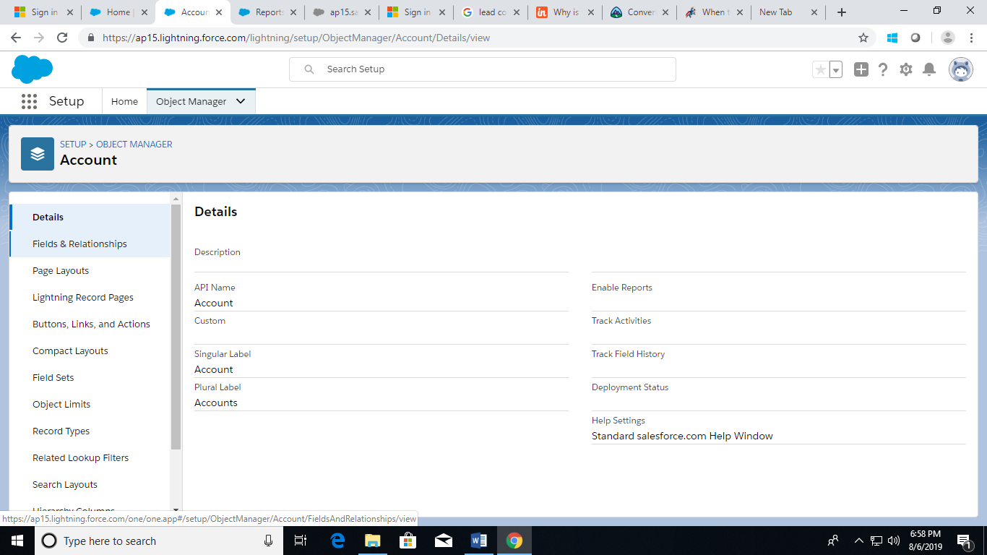

1. Call your field Account Number and select Text for the formula return type and click Next.

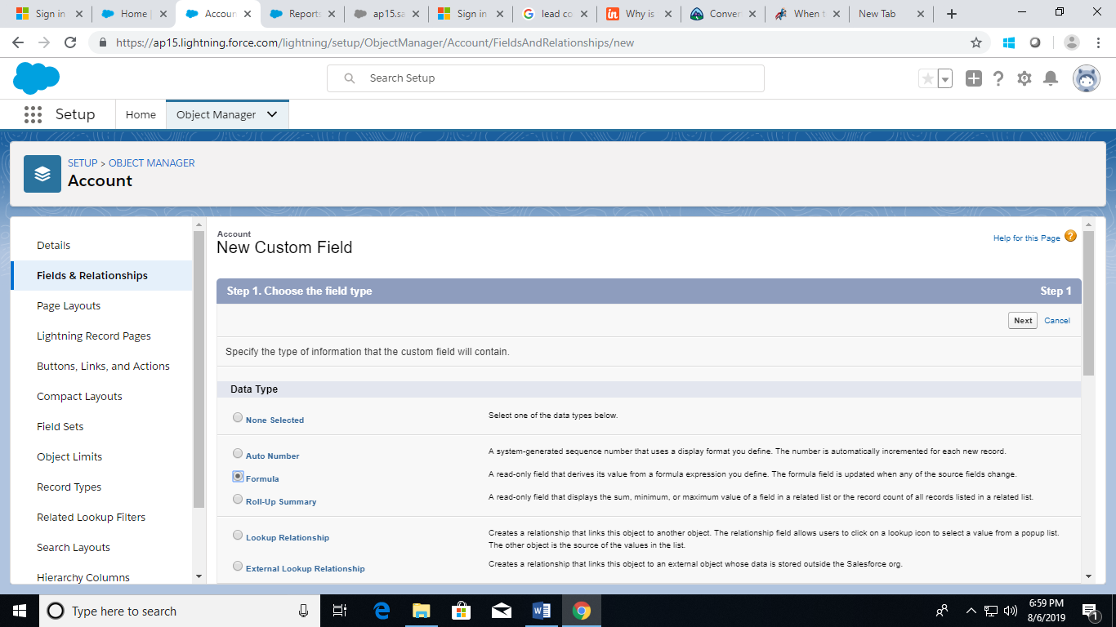

1. Click Insert Field on the Advanced Formula Editor.

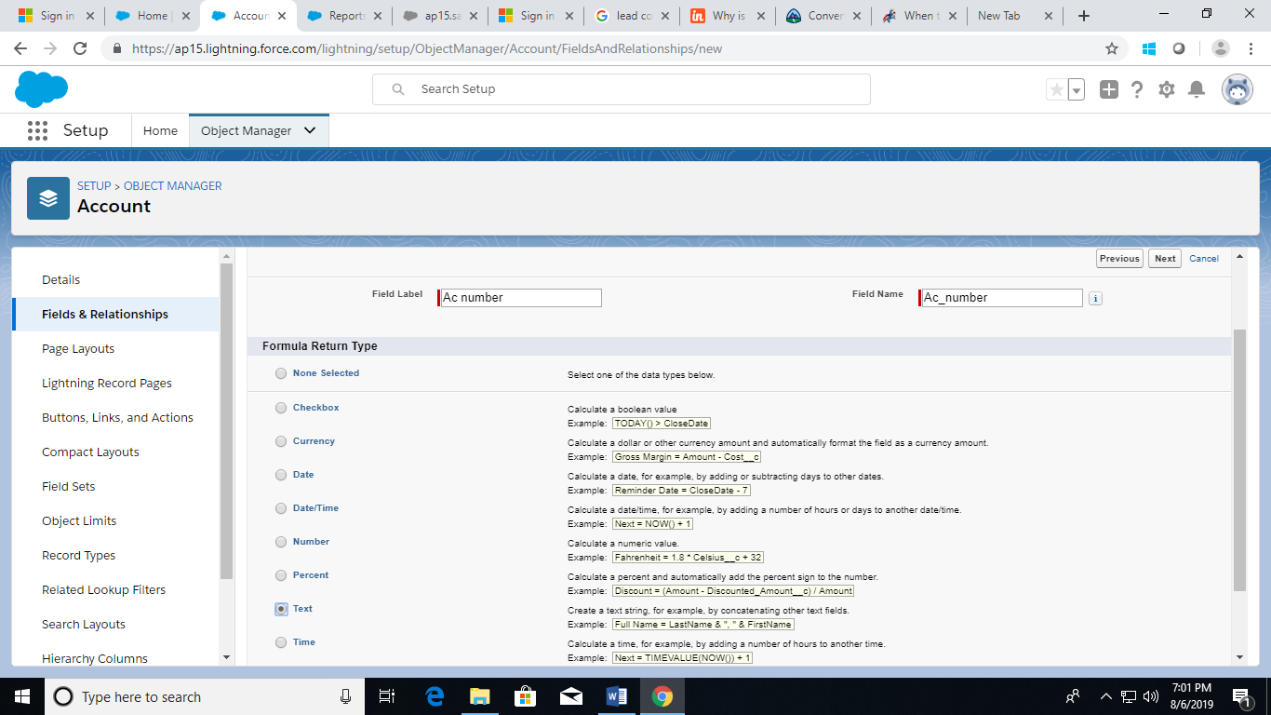

1. Select Contact | Account | Account Number and then click Insert.

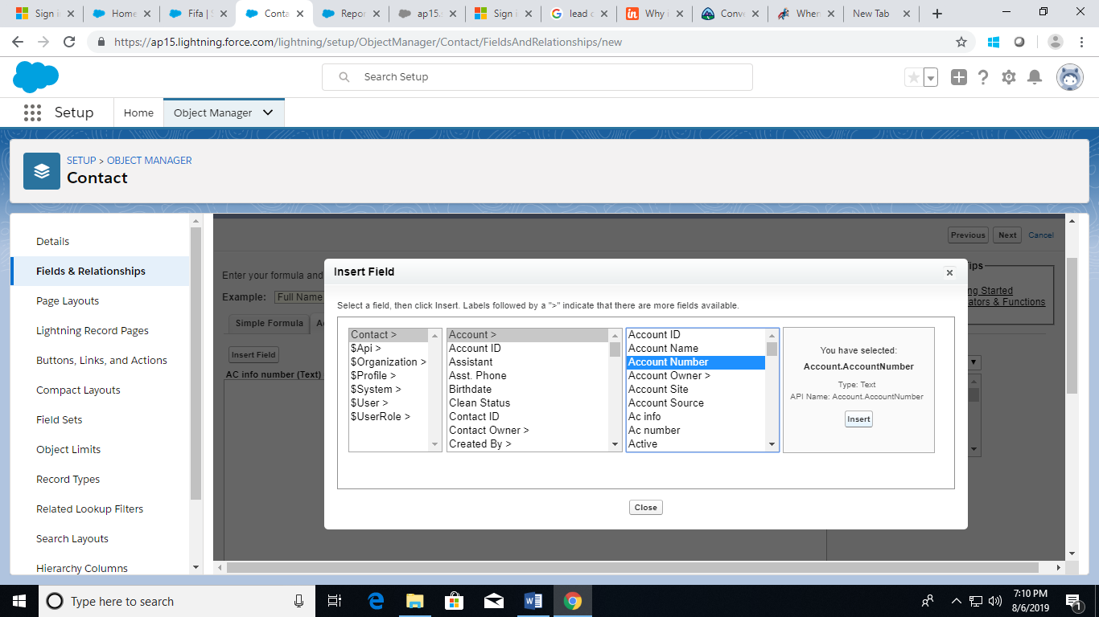

1. Set the field level security.
2. Click on Next and then on Save.